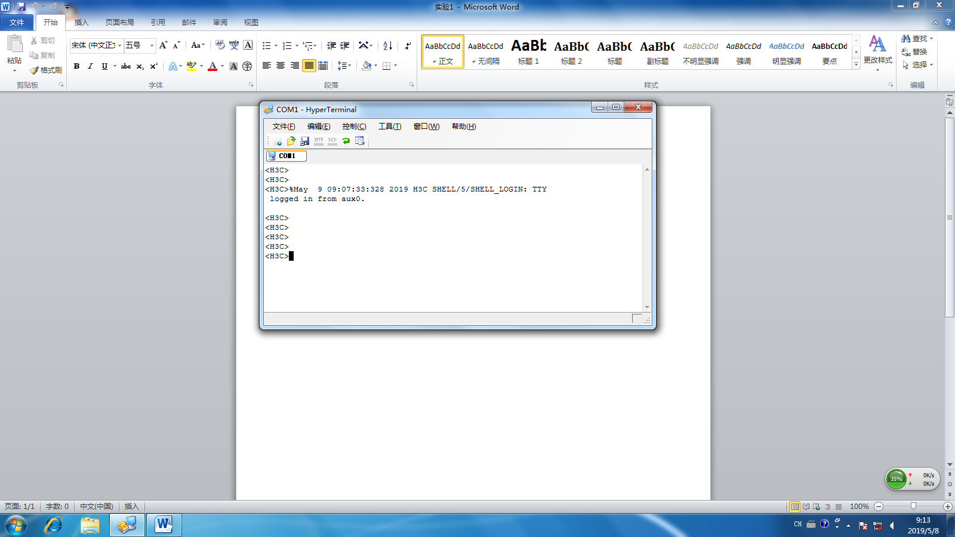

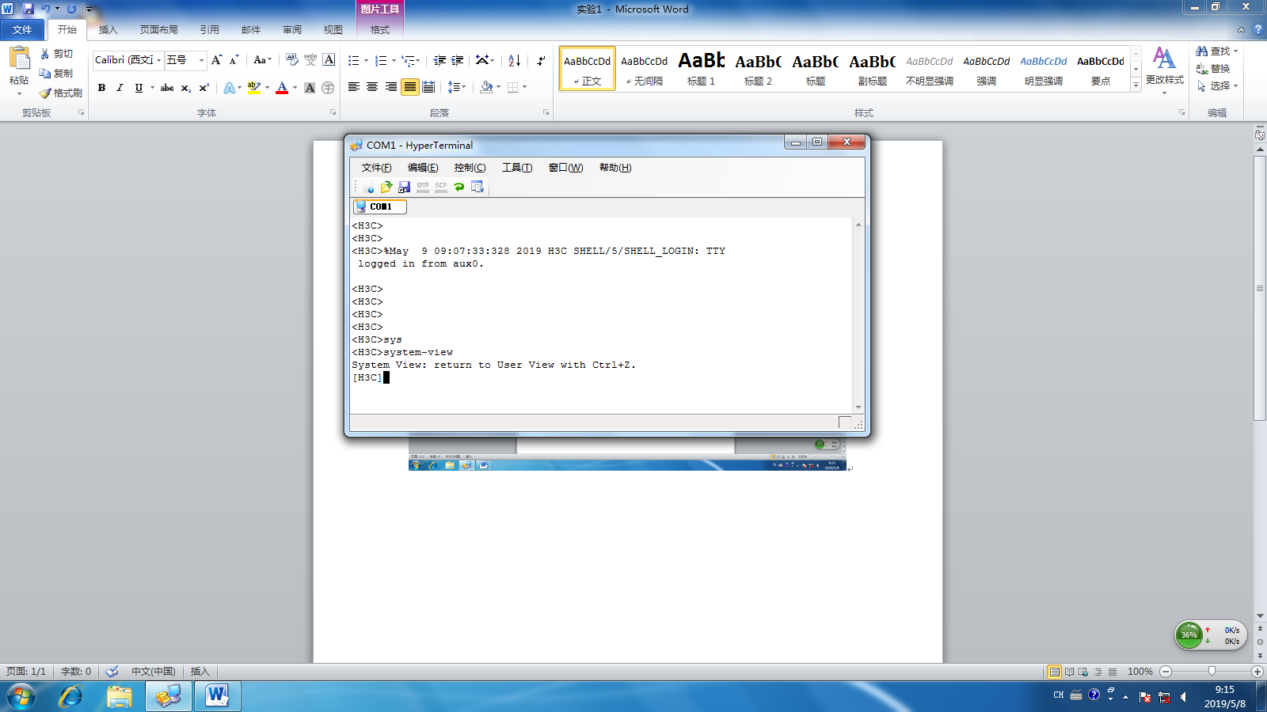

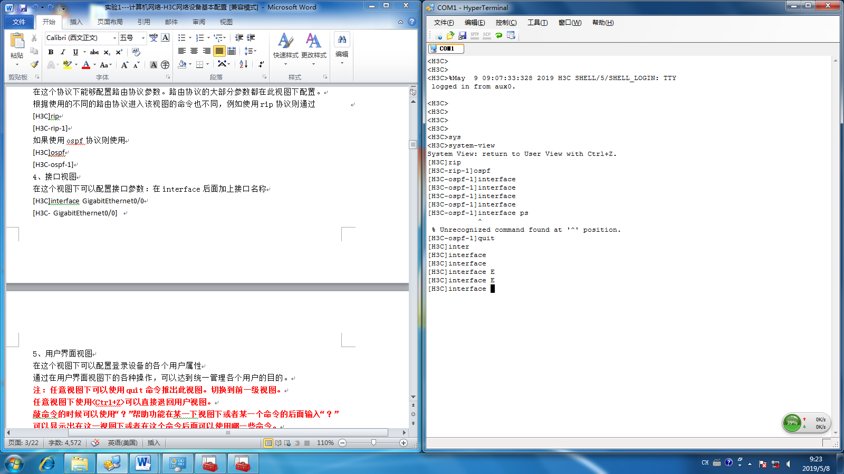

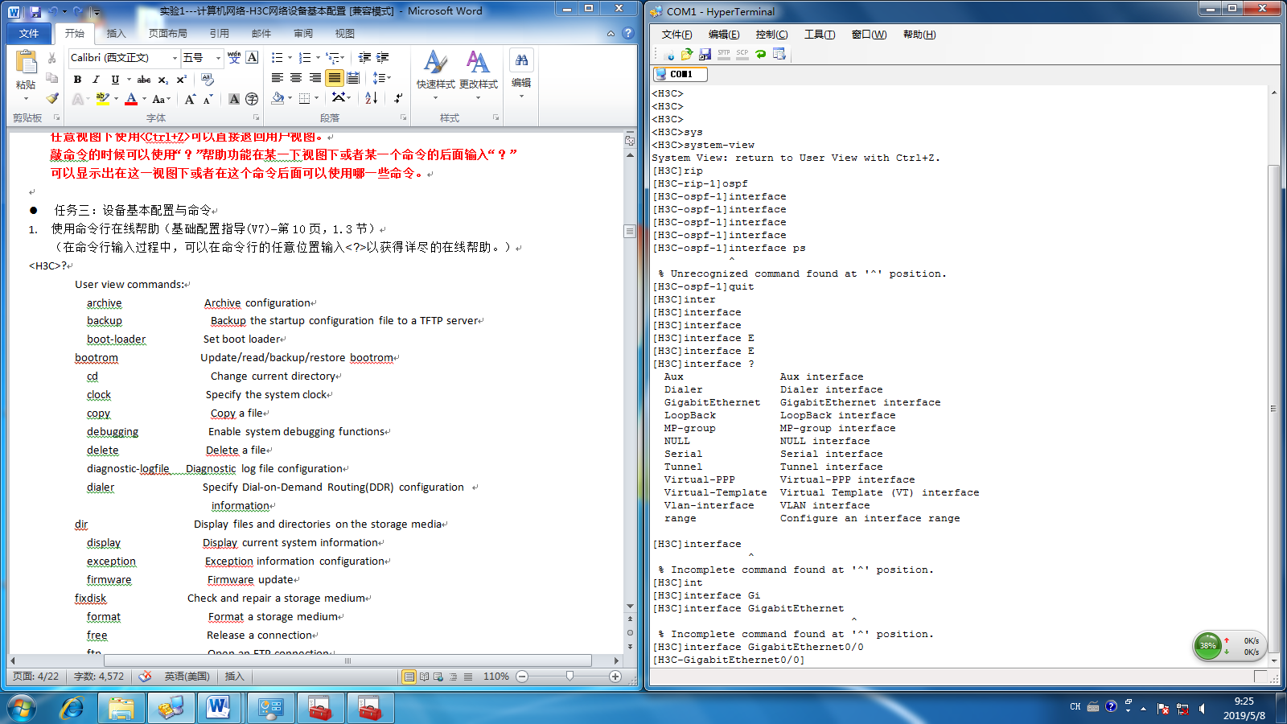

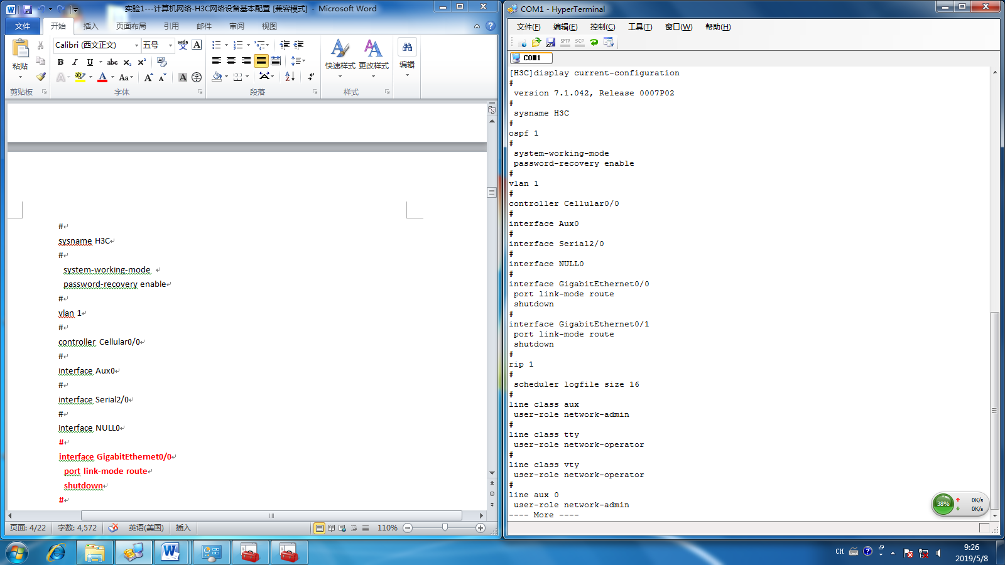

[H3C]display current-configuration

#

version 7.1.042, Release 0007P02

#

sysname H3C

#

ospf 1

#

system-working-mode

password-recovery enable

#

vlan 1

#

controller Cellular0/0

#

interface Aux0

#

interface Serial2/0

#

interface NULL0

#

interface GigabitEthernet0/0

port link-mode route

shutdown

#

interface GigabitEthernet0/1

port link-mode route

shutdown

#

rip 1

#

scheduler logfile size 16

#

line class aux

user-role network-admin

#

line class tty

user-role network-operator

#

line class vty

user-role network-operator

#

line aux 0

user-role network-admin

#

line vty 0 63

user-role network-operator

#

domain system

#

aaa session-limit ftp 16

aaa session-limit telnet 16

aaa session-limit http 16

aaa session-limit ssh 16

aaa session-limit https 16

domain default enable system

#

role name level-0

description Predefined level-0 role

#

role name level-1

description Predefined level-1 role

#

role name level-2

description Predefined level-2 role

#

role name level-3

description Predefined level-3 role

#

role name level-4

description Predefined level-4 role

#

role name level-5

description Predefined level-5 role

#

role name level-6

description Predefined level-6 role

#

role name level-7

description Predefined level-7 role

#

role name level-8

description Predefined level-8 role

#

role name level-9

description Predefined level-9 role

#

role name level-10

description Predefined level-10 role

#

role name level-11

description Predefined level-11 role

#

role name level-12

description Predefined level-12 role

#

role name level-13

description Predefined level-13 role

#

role name level-14

description Predefined level-14 role

#

user-group system

#

return

